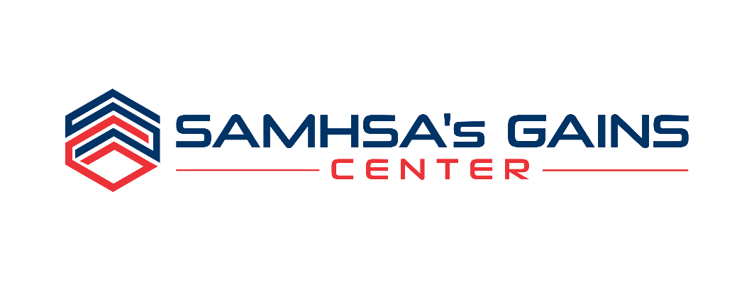

Solicitation for Applications

Sequential Intercept Model Mapping Workshops

Please complete this application in its entirety to ensure that we have SUFFICIENT background information on your Jurisdiction and that the Required level of commitment among Key Stakeholders is CLEARLY demonstrated.
NOTE: Incomplete applications will not be considered.

PLEASE RETURN THIS APPLICATION VIA E-MAIL* OR POSTAL MAIL BY November 13, 2020:

Attn: Matthew Robbins, SIM Workshop Coordinator
E-mail: mrobbins@prainc.com
Phone: 1.800.311.4246 or 518.439.7415 Ext. 5234

SAMHSA’s GAINS Center
Policy Research Associates, Inc.
345 Delaware Avenue
Delmar, NY 12054

*NOTE: Strong preference is given for complete emailed applications.

Overview
SAMHSA’s GAINS Center for Behavioral Health and Justice Transformation, operated by Policy Research Associates, Inc. (PRA), is known internationally for its work regarding individuals with behavioral health needs who are involved in the criminal justice system.

For the past several years the GAINS Center has solicited applications from jurisdictions interested in better identifying and responding to the needs of individuals with behavioral health needs who are involved or at risk for involvement in the criminal justice system, through Sequential Intercept Model Mapping Workshops (SIM Workshops). SIM Workshops are designed bring together a local, cross-system, multidisciplinary group of key stakeholders from a particular jurisdiction to facilitate cross-system collaboration and to identify and discuss ways in which barriers in and between the criminal justice and behavioral health systems can be reduced through the development of integrated local strategic action plans.

NOTE: All SIM Mapping Workshops under this solicitation are currently being planned to be held virtually.

Purpose & background

SIM Workshops result in a map that illustrates how people with behavioral health needs come in contact with and flow through the criminal justice system utilizing the framework of the Sequential Intercept Model. SIM Mapping workshops bring together key stakeholders to create a local “systems map” and establish local priorities for change and strategic plans.

The Sequential Intercept Model

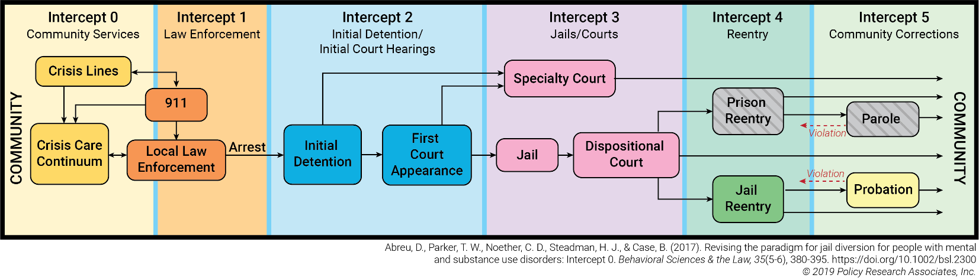

During the SIM workshop, resources and opportunities are identified at each intercept for identifying individuals with behavioral health needs and diverting them out of the criminal justice system and into appropriate community-based treatment programs. As part of the mapping process, critical gaps are also identified and summarized. Based on the identified gaps, opportunities for improvement and systems change are discussed. Participants determine areas where immediate action will result in a more cohesive, integrated approach to service delivery, and a local set of priorities for change is established. The local set of priorities for change become the focus of strategic action plans. Throughout this process, the GAINS Center staff provide examples of successful systems integration and promising programs from around the country.

Site Selection

SAMHSA’s GAINS Center for Behavioral Health and Justice Transformation will provide SIM Workshops free of charge to selected jurisdictions between February and July 2021. There are no fees for registration, tuition, or materials associated with these workshops. The GAINS Center will cover all costs associated with pre- and post-workshop planning and coordination, facilitator time, data collection and analysis, and report development.

To be considered, all applications must be received by November 13, 2020. Selected communities will be notified on or before December 4, 2020.

target audience/Workshop Participants
The target audiences for this workshop are criminal justice system professionals, including judges, prosecutors, defense attorneys, 9-1-1 dispatchers, law enforcement and other first responders, jail administrators and correctional officers, pre-trial services, probation and parole officers, human service providers, and persons with lived experience. Since the workshop is highly interactive in nature, to achieve maximum participation for all attendees, each workshop is limited to 50 participants.

NOTE: Participants must have access to a computer, webcam, internet service, and have the ability to connect to the Zoom virtual meeting platform.

TARGET ATTENDEE GROUPS:
- Criminal Justice System Professionals (judges and court personnel, prosecutors, defense attorneys, dispatchers and law enforcement, jail administrators and correctional officers, pre-trial services, probation and parole officers)
- Mental Health Professionals (psychologists, psychiatrists, social workers, supervisors, program managers, administrators, etc.)
- Substance Use Professionals (chemical dependency counselors, substance use specialists, supervisors, program managers, administrators, etc.)
- Housing and Community Support Services (housing providers, local Social Security and Medicaid agency representatives, etc.)
- First Responders/Crisis Services (EMS, mobile crisis, detoxification services, suicide prevention staff, domestic violence workers)
- Peers and Family Members (persons with lived experience in the local behavioral health and criminal justice system), including local Peer-Run and Family-Run Organizations
- Religious and Cultural Organizations and Local Foundations
- Elected Officials

KEY STAKEHOLDER PARTICIPANTS:
- Judges (particularly those who preside over first appearance courts and treatment/specialty courts)
- District Attorney’s Office
- Public Defender’s Office
- Treatment Court Coordinator(s) and Case Managers
- Administrators from the local police department(s) and county sheriff’s office;
- Administrator from the local jail;
- Administrator from the local probation department(s);
- Administrator from the local public mental health agency (e.g., county mental health department);
- Administrator from the local public substance use agency;
- Administrator from the local housing authority;
- Administrators from the local Social Security and Medicaid agencies;
- Veteran Justice Outreach Specialists
- Individuals with lived experience in both the criminal justice and behavioral health systems

Application Requirements

It is required that each applicant submitting an application for consideration identify and engage leaders within their jurisdiction that support this project and are dedicated to allocating staff time to participate in the workshop and related activities.

Please provide letters of support from the following (required):

- Law enforcement
- Jail
- Court(s)
- Mental health and substance use services
- Probation Department

Additionally, applicants selected to receive SIM Workshops must agree to participate in the following:

- 2-3 pre-workshop planning conference call(s) with GAINS Center staff and consultants;
- Local planning activities on an as needed basis to select workshop dates, identify and invite workshop participants, etc.
- Pre-workshop inventory of existing resources, policies, and programs;
- Pre-workshop community self-assessment of level of collaboration and perceptions of criminal justice and behavioral health issues (repeated at 6- and 12-months post-workshop);
- Pre-workshop data collection around specific community impact measures and progress indicators (repeated at 6-, 12-, 18-, and 24-months post-workshop);
- 2-3 virtual meetings, each 3-4 hours in length.

Note: A written agreement regarding requirements related to pre- and post-SIM Workshop data collection and analysis must be reviewed and accepted by applicants selected to receive SIM Workshops before the award is final.

Following the workshop, communities will receive a list of identified priorities for change, copies of draft local strategic action plans, a full comprehensive report, and a detailed systems map. Additionally, communities will be provided with the results of the community self-assessment and quantitative and qualitative data and information regarding the impact of the SIM workshop and progress following it.

Since the SIM workshop is designed to bring jurisdictions that may be at varying “points of readiness” through a series of exercises that culminate in a comprehensive systems map and a set of local priorities for change with concrete action steps, “readiness for change” is a critical element to determine if the SIM workshop fits the needs of a given jurisdiction. “Readiness for change” is a subjective term requiring the review of how well your mental health, criminal justice, and substance use services are integrated. To determine which applicants would benefit most from the SIM workshop, it is important to evaluate your jurisdiction using a scale that assesses integration on a scale from ‘information sharing’ through ‘full integration’ (Konrad, 1996):

Intensity of Integration Continuum
Informal
Formal
1 | 2 | 3 | 4 | 5 | 6 | 7 | 8 | 9 | 10
Information Sharing Cooperation &
& Communication Coordination Collaboration Consolidation Integration

Level | Activities
Information Sharing and Communication | - Talk with one another  - Willingness to help on ad hoc basis  - Share information
Cooperation and Coordination | - Do joint planning on specific program components  - Joint staff meetings  - Factor in what is happening on other side when operating programs  - Coordinate client referral process
Collaboration | - Informal/formal joint planning  - Joint funding  - Written MOUs; interagency agreements  - Effort to share funding/services
Consolidation | - Formalized joint planning  - Regular meetings of key players  - Cross-training of staff  - Designated planning council  - Clients seen as shared responsibility
Integration | - Shared funding of key positions (boundary-spanners)  - Unified intake and assessment  - Joint budget development

sequential intercept mapping (sim) workshop

SITE Application

Please complete the application below.
Only complete applications will be considered for site selection.

APPLICANT JURISDICTION/COMMUNITY: _________________________________________________________________________________

NAME OF PERSON COMPLETING THIS FORM:
TITLE:
ORGANIZATION:
ADDRESS:
PHONE:
EMAIL:

PLEASE COMPLETE AND ATTACH A SEPARATE STATEMENT TO THIS APPLICATION THAT ADDRESSES THE APPLICANT EVALUATION CRITERIA BELOW. YOUR STATEMENT SHOULD BE A MAXIMUM OF FIVE PAGES IN LENGTH, AND SHOULD CLEARLY INDICATE WHY YOUR Jurisdiction SHOULD BE SELECTED TO RECEIVE A SIM WORKSHOP.

Please address the following in your statement:

- Using the Intensity of Integration Continuum (Page 5), identify the level that your jurisdiction is currently at (choose only one):

- Information Sharing and Communication
- Cooperation and Coordination
- Collaboration
- Consolidation
- Integration

- Describe the current efforts that put you into that category (e.g., MOUs in place, joint staff meetings, etc.).

- Provide a brief description of your jurisdiction (including demographics, population, available resources, and any other information that you think gives us a good “picture” of your community).

- Are any of the agencies/organizations that are party to this application currently receiving grant funding from SAMHSA? If so, please indicate the specific grant award(s) and a brief description of the grant activities.

- Discuss current policies, strategies, and programs that have already been developed to better identify and respond to the needs of adults with mental and substance use disorders in contact with the criminal justice system (e.g., creation of an interagency planning group; adoption of uniform screening and assessment measures, diversion program, etc.).

- Describe any current plans to enhance existing policies or services for this population (e.g., law enforcement specialized response, specialized behavioral health crisis response, pretrial release, adoption of uniform screening and assessment measures, diversion program, etc.).

- Discuss 2-3 specific goals that your community hopes to achieve by participating in the SIM Workshop.

- Is your jurisdiction interested in exploring data-guided strategies to address racial inequities and disparities in the criminal justice and behavioral health systems? If so please explain, providing specific information about access to data and information systems that could help inform these efforts, also describing any current efforts that are underway.

- Discuss any obstacles or hurdles you anticipate in regard to adhering to the schedule or expectations of this opportunity.

- Briefly describe why it is important for your jurisdiction to receive this workshop right now.

Please identify a primary contact for your jurisdiction, if it is someone different than the applicant. Please ensure the primary contact is someone who will be accessible to the participants and to GAINS Center staff for pre- and post-training activities.

PRIMARY CONTACT FOR THIS APPLICATION
Primary Contact Name: _________________________________________________________________________________________

Role/Position: ___________________________________________________________________________________________________

Agency: ___________________________________________________________________________________________________________

Address: __________________________________________________________________________________________________________

City/State/Zip: ___________________________________________________________________________________________________

Phone: __________________________________________________

Fax: _____________________________________________________

E-mail: __________________________________________________

Please identify the lead agencies/organizations that have agreed to participate in the sequential intercept mapping (sim) workshop.
If you have additional agencies or organizations that plan to attend, please identify them using the “other” category. If there are multiple agencies of the same type, please copy the corresponding table(s) and include this information for each agency separately.

Law Enforcement
Agency Name:
Address:

Lead Contact
Name:
Agency:
Address:
City, State, Zip:
Phone:
Fax:
Email:

Jail
Agency Name:
Address:

Lead Contact
Name:
Agency:
Address:
City, State, Zip:
Phone:
Fax:
Email:

Court
Agency Name:
Address:

Lead Contact
Name:
Agency:
Address:
City, State, Zip:
Phone:
Fax:
Email:

District Attorney’s Office
Agency Name:
Address:

Lead Contact
Name:
Agency:
Address:
City, State, Zip:
Phone:
Fax:
Email:

Public Defender’s Office
Agency Name:
Address:

Lead Contact
Name:
Agency:
Address:
City, State, Zip:
Phone:
Fax:
Email:

Probation
Agency Name:
Address:

Lead Contact
Name:
Agency:
Address:
City, State, Zip:
Phone:
Fax:
Email:

Housing
Agency Name:
Address:

Lead Contact
Name:
Agency:
Address:
City, State, Zip:
Phone:
Fax:
Email:

Other
Agency Name:
Address:

Lead Contact
Name:
Agency:
Address:
City, State, Zip:
Phone:
Fax:
Email:

Other
Agency Name:
Address:

Lead Contact
Name:
Agency:
Address:
City, State, Zip:
Phone:
Fax:
Email:

Other
Agency Name:
Address:

Lead Contact
Name:
Agency:
Address:
City, State, Zip:
Phone:
Fax:
Email:

Thank you! SAMHSA’s GAINS Center sincerely appreciates your interest in this opportunity.

PLEASE RETURN THIS APPLICATION VIA E-MAIL* OR POSTAL MAIL BY November 13, 2020:

Attn: Matthew Robbins, SIM Workshop Coordinator
E-mail: mrobbins@prainc.com
Phone: 1.800.311.4246 or 518.439.7415 Ext. 5234

SAMHSA’s GAINS Center
Policy Research Associates, Inc.
345 Delaware Avenue
Delmar, NY 12054

Questions should be directed to Matthew Robbins at the phone number and email address listed above.

Incomplete applications will not be considered.

Late submissions will not be accepted or reviewed without prior approval by the GAINS Center.

If additional time in needed to complete this application or obtain the required letters of support you must contact the GAINS Center to request an extension of the application deadline.

All applicants will receive notification regarding the status of their application on or before December 4, 2020. Notification will be distributed via email.

*NOTE: Strong preference is given for complete emailed applications.

